
WEb DEVelopment: WeDE5020
Student number: ST10526546


author: Lesedi Mulaudzi

Website Project Proposal: Joe's Bakery
1. Organisation Overview
Organisation Name:
Joe’s Bakery
Brief History of the Organisation:
Joe's Bakery is a local small business that provides freshly baked goods to customers in the surrounding community. The bakery sells a variety of products, including freshly baked bread, muffins, cookies and custom celebration cakes.
For the purpose of this website project, Joe's Bakery will be presented as a customer-focused local bakery that aims to provide fresh baked products and custom cakes for different occasions.
Mission Statement:
The mission of Joe's Bakery is to provide customers with fresh, quality baked goods and custom cakes while offering friendly and convenient service.
Vision Statement:
The vision of Joe's Bakery is to become a well-known local bakery by providing quality products and making it easier for customers to discover and order its baked goods.
Target Audience
The target audience includes:
- Local residents.
- Families.
- Students.
- Businesses.
- Customers looking for freshly baked goods.
- Customers looking for custom celebration cakes.

2. Website Goals and Objectives
The main goal of the proposed website is to give Joe's Bakery a professional online presence where customers can easily find information about the bakery and its products.
Website Goals:
The website will aim to:
- Increase awareness of Joe's Bakery.
- Display the bakery's products in an organised way.
- Make it easier for customers to enquire about custom cakes.
- Provide customers with the bakery's opening hours and location.
- Make contact information easy to find.
- Attract new customers.
- Encourage customers to visit the bakery or make enquiries.
A website could help Joe's Bakery attract new customers and potentially increase sales.
Key Performance Indicators (KPIs):
The success of the website could be measured using:
- Number of website visitors.
- Number of product pages viewed.
- Number of custom cake enquiries.
- Number of contact form submissions.
- Number of customers accessing the location and business hours.
- Number of enquiries received through the website.
- Customer feedback about the website's usability.

3. Current Website Analysis
Current Website Status:
Joe's Bakery currently does not have a website.
Because there is no existing website, there are no existing website strengths or weaknesses to analyse.
Identified Opportunity:
The main opportunity is to create a website from the beginning that focuses on what customers need when looking for a local bakery.
The website should make it easy for customers to:
- See available products.
- Learn about custom cakes.
- Find business hours.
- Find the bakery's location.
- Contact the bakery.
- Make product or cake enquiries.

4. Proposed Website Features and Functionality
Home Page:
The homepage will introduce Joe's Bakery and highlight its main products. It can also include attractive images of baked goods and clear buttons directing customers to the products and contact pages.
About Us Page:
This page will provide information about Joe's Bakery, its purpose and the type of products it offers.
Products Page:
The products page will display the bakery's main products, including:
- Fresh bread.
- Muffins.
- Cookies.
- Custom celebration cakes.
Each product can include an image, short description and relevant information.
Custom Cakes Page:
This page will focus specifically on custom celebration cakes. It can explain the custom cake service and allow customers to submit an enquiry with information such as the type of cake they are interested in and the date required.
Gallery Page:
The gallery will display photographs of the bakery's products and custom cakes. This will allow potential customers to see examples of the products before making an enquiry.
Contact Us Page:
The contact page will provide:
- Phone or email contact information.
- Business hours.
- Bakery location.
- Contact/enquiry form.
- Location map if appropriate.
Navigation
A simple navigation bar will allow users to move easily between the Home, About, Products, Custom Cakes, Gallery and Contact pages.

5. Design and User Experience
Overall Design Approach:
The website will use a warm, welcoming and professional design that reflects the bakery's products. The main focus will be on making the products visually appealing while keeping the website easy to navigate.
Colour Scheme
Proposed colour palette:
- Cream – for a warm and clean background.
- Light brown – to create a bakery-inspired feel.
- Dark brown – for headings and important text.
- Soft yellow – to create a welcoming and friendly appearance.
Typography
The website will use fonts that are attractive but easy to read.
Proposed font choices:
- Headings: Poppins or Montserrat.
- Body text: Arial, Open Sans or another simple sans-serif font.
Headings will be larger and more prominent so customers can quickly understand each section.
Layout and Design
The website will use:
- A clear navigation bar.
- Large product images.
- Product cards for displaying baked goods.
- Clear headings.
- Easy-to-see buttons.
- Consistent spacing.
- A simple footer containing contact information.
User Experience Considerations:
The website should allow customers to find products and important business information quickly.
For example, a customer looking for a custom celebration cake should be able to reach the custom cake page without having to search through multiple pages.
The website should also be responsive so that customers can use it comfortably on mobile phones, tablets and computers.
Low-Fidelity Wireframes:
Low-fidelity wireframes will be created before development begins. These will show the basic layout and information hierarchy of the website.
The wireframes will include the proposed placement of:
- Logo.
- Navigation menu.
- Product images.
- Product information.
- Buttons.
- Contact information.
- Enquiry form.
- Footer.
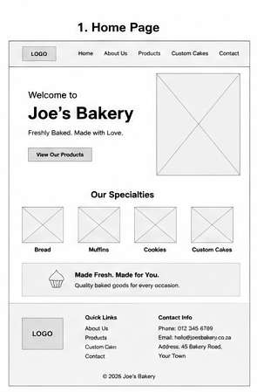
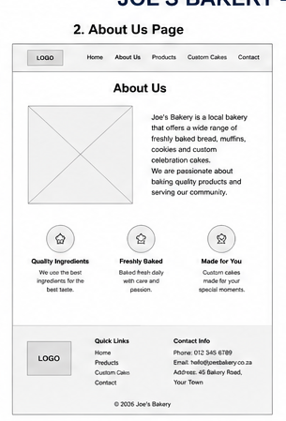

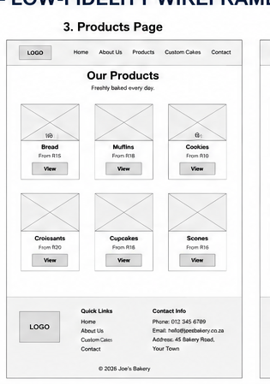

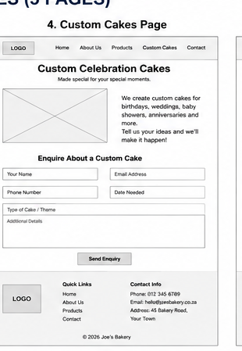

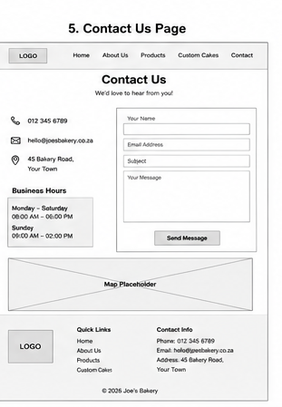

6. Technical Requirements
The website will be developed using standard web development technologies.
Proposed Technologies
- HTML – to create the structure of the website.
- CSS – to control the design, layout, colours and typography.
- JavaScript – to provide interactive functionality where required.
Hosting and Domain
The website will require:
- A suitable domain name based on Joe's Bakery.
- Web hosting.
- An SSL certificate for a secure HTTPS connection.
The final hosting provider and domain will be selected based on cost, reliability and suitability for the business.

7. Timeline and Milestones
The project will follow the subject's required submission dates.
Stage | Activity
1 | Research Joe's Bakery and complete the project proposal
2 | Identify website requirements and gather content
3 | Plan website structure and navigation
4 | Create low-fidelity wireframes
5 | Develop the website structure using HTML
6 | Apply the design using CSS
7 | Add interactive features using JavaScript
8 | Add products, images and business information
9 | Test the website on different devices and screen sizes
10 | Fix errors and improve the user experience
11 | Finalise the website and prepare the submission
8. Budget
The following is a proposed estimated budget for developing and maintaining the website:
Item | Estimated Cost
Domain registration | R250 per year
Web hosting | R1,200 per year
SSL certificate | R0 – R500 per year
Website development | R4,000
Website testing and optimisation | R1,000
Maintenance and updates | R1,500 per year
Estimated first-year total | R7,950 – R8,450

